|  |  |  |  |
| --- | --- | --- | --- |
| **Lyng Primary School Knowledge Organiser** | | | |
| **Topic:** | **Fieldwork – Can I carry out an independent fieldwork enquiry?** | Year 6 | Summer Term |

|  |  |
| --- | --- |
| **What Step On and Goldilocks words will I use?** | |
| **Spelling** | Related image**Definition** |
| Analyse | To look at something in detail |
| Audience | People who receive a message or watch a performance |
| Data | Number or facts collected to prove something. |
| Enquiry | An investigation into a question |
| Impact | The influence one thing has on another |
| Improvement | To make something better than it was |
| Present | To show something to other people |
| Process | A society where one religion is dominant. |
| Risk | A situation where something may be dangerous |
| Route | A way to get from one place to another, marked on a map |
| Viewpoint | A particular way of thinking about something. |

Image result for steps clip art

**Enquiry questions that we shall investigate during the topic:**

**Significant places**

* Britain
* Sandwell
* West Bromwich
* How can I develop an enquiry question?
* What are the most effective methods of data collection?
* How do you plan a route for fieldwork?
* What data can you collect to answer an enquiry question?
* What is the answer to my enquiry question?
* How do I present my results?



|  |
| --- |
| **Data Collection methods** |
|  |

The children will evaluate which data collection methods are appropriate for different types of fieldwork.

Afterwards they will then decide which data collection method will be most effective for their chosen enquiry.

|  |
| --- |
| **The enquiry circle** |
|  |

**What is the enquiry process?**

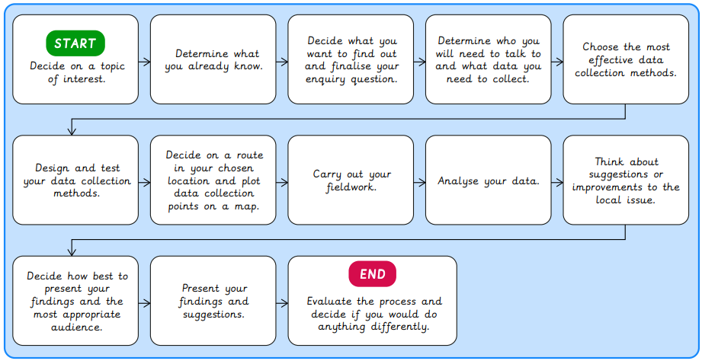

**Fieldwork Opportunities**

This whole unit is an opportunity to explore and develop fieldwork.

|  |  |  |  |
| --- | --- | --- | --- |
| **Lyng Primary School Knowledge Quiz** | | | |
| **Geography Topic:** | **Fieldwork** | Year 6  *Civilisations, Communication and Inventions* | Summer |

|  |  |  |
| --- | --- | --- |
| 1. An enquiry is… | **S** | **E** |
| 1. Drawing a tally chart |  |  |
| 1. Filling out a questionnaire |  |  |
| 1. An investigation into a question |  |  |
| 1. Reading a local newspaper |  |  |

|  |  |
| --- | --- |
| 5. A questionnaire should… | |
|  | 1. Only have one question |
|  | 1. Include a photograph or diagram |
|  | 1. Be full of facts and detail |
|  | 1. Be quick and easy to answer. |

|  |  |  |
| --- | --- | --- |
| 1. Which method would be best for collecting data showing the number of vehicles passing a point? | **S** | **E** |
| a) A photograph |  |  |
| b) An audio clip |  |  |
| c) A questionnaire |  |  |
| d) A tally chart |  |  |

|  |
| --- |
| 6. Why is it important to plan a route before your trip? |
| 1. So you do not waste time |
| 1. So you do not get lost |
| 1. So that you are collecting data in appropriate locations |
| 1. All of the above. |

**Fieldwork Geography Quick Quiz**

|  |  |  |
| --- | --- | --- |
| 4. A Likert scale is used to… | **S** | **E** |
| a) capture beautiful scenery |  |  |
| b) capture environmental quality |  |  |
| c) show the location of features |  |  |
| d) interview someone. |  |  |

|  |  |  |
| --- | --- | --- |
| 1. Which method would be best for collecting somebody’s opinion about a new shop opening? | **S** | **E** |
| a) A photograph |  |  |
| b) An interview |  |  |
| c) A tally chart |  |  |
| d) A sketch map |  |  |

|  |  |
| --- | --- |
| 7. Which map is best to use to plan a car journey from Newbury to Reading? | |
| **S** |  |
| **E** |  |

